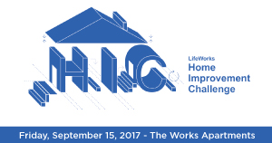

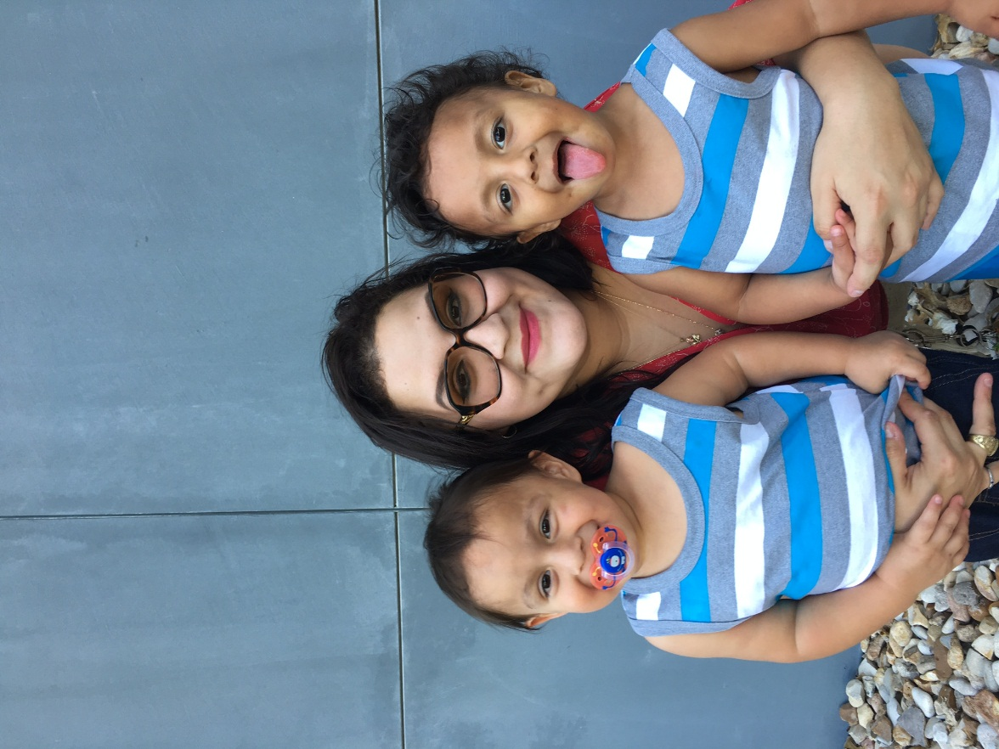**Team Name: Legacy Circle Team**

**Client Name:** Miranda (21)

Victoriano (2 ½ years)

Valentino (2 ½ years)

**Apartment:** 212 (2 bedroom)

Miranda was born in Austin, grew up in Manor, but then moved back to Austin after her parents separated when she was 12 years old. She has one older sister and one younger brother. Miranda graduated from high school at the age of 16, and began working at Wendy's, then at Goodwill until she was 18. At that time, she became pregnant and had to stop working due to her high-risk pregnancy.

Miranda's cousin, who was attending LifeWorks GED Program, told her about the Young Parents Program (YPP) offered at LifeWorks. Miranda applied and was accepting into YPP and moved into The Works with her two sons in September 2016.

Today, Miranda is a full-time mom to twin boys. She thinks being a mom is the hardest but most important job because you get to see your children become the people that they are meant to be. She says her boys are so different from each other. Victoriano is like a "superboy", playing with cars and making dinosaur noises. Valentino has a "teddy bear" personality and likes stuffed animals and puppies.

Once the boys get older, Miranda plans to go back to school for social work. She wants to help people, because she's likes making people happy. Eventually she would like to have her own home, maybe in the country with a little farm.

Miranda says LifeWorks has helped her a lot -- from being more responsible to being a better mom, and even a better person. Her LifeWorks experience is what shaped her desire to go into social work, so that she can give back, too.